
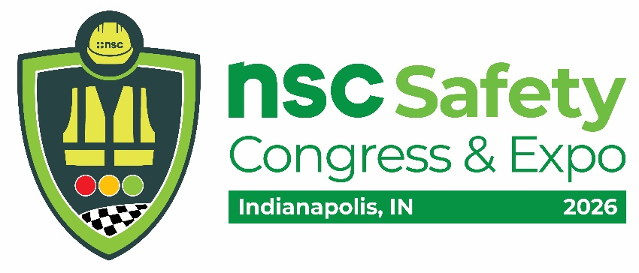
For your SAFETY, all Congress buses have Seatbelts!

SHUTTLE INFORMATION

HOURS OF OPERATION

MONDAY, SEPTEMBER 14
7 a.m. – 10 a.m.
Departs every 30 minutes
10 a.m. – 3 p.m.
Departs every 30 minutes
3 p.m. – 5:30 p.m.*
Departs every 30 minutes

TUESDAY, SEPTEMBER 15
7 a.m. – 10 a.m.
Departs every 30 minutes
10 a.m. – 3 p.m.
Departs every 30 minutes
3 p.m. – 5:30 p.m.*
Departs every 30 minutes

WEDNESDAY, SEPTEMBER 16
7 a.m. – 10 a.m.
Departs every 30 minutes
10 a.m. – 12:30 p.m.
Departs every 30 minutes
12:30 p.m. – 3 p.m.*
Departs every 30 minutes

*Last bus departs from the hotels to the Convention Center one hour prior to the end of service

HOTEL ROUTES & BOARDING LOCATIONS

RED ROUTE ONE
The Alexander Curbside in Front of Hotel

For hotel shuttle information
or to arrange ADA transportation (lift-equipped vehicle)
Call or Text 407-485-4649

Please request ADA transportation at least 60 minutes prior to the time you will need to be picked up

Please note that this phone number is monitored during active shuttle hours ONLY

Transportation Managed by: The Convention Store, Inc.

Shuttle transportation provided by:
TCS Transportation
(A Division of The Convention Store, Inc.)

